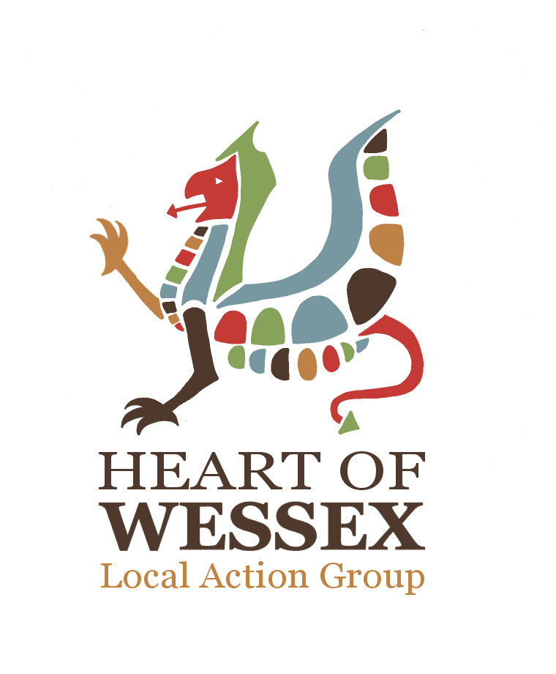
Elections to the Local Action Group Executive Committee

We need you!

The interim Heart of Wessex Executive Committee steps down at the LAG Forum meeting on Wednesday 16th March 2016. They have done a wonderful job getting the Programme up and running, and off to a great start - always the most difficult part of any Programme. This means that we now need to ask for volunteers who would like to stand for election to form the new Executive Committee.

The key principles of the Executive Committee are:

- Group not too large to enable decisions to be made, max of 15
- Representation from key partners
- Balance of private, public and community sector representation
- Limit of no more than 49% public sector representation
- Achieving a balance between the geographical areas, (Wiltshire/Somerset)
- Achieving a balance between the National LEADER Priorities and the Heart of Wessex LAG Strategic Objectives
- Key Programme and partners able to be involved in a non-voting capacity
- Right skills and experience to get the Programme started and delivering quickly and effectively
- Independent Chair

This is a great opportunity to get more involved in the Programme. Of the 15 seats available on the Committee, 6 go to the core partner organisations of:

- Cranborne Chase and West Wiltshire Area of Outstanding Natural Beauty
- South Somerset District Council
- Frome Town Council
- Mendip District Council
- Wiltshire Council
- Wincanton Community Venture

1 seat is then allocated for a representative from the Youth LAG, and one for the Local Action Group Forum Chairman. The remaining 7 seats are elected from the Local Action Group. These are the seats that we need you to volunteer for!

Your roles and responsibilities as an Executive Committee member would include:

- To be representative, support the inclusive nature of the LAG, and provide skills and knowledge to help assess applications
- Support the LAG and its Chairmen
- Construct the annual Delivery Plan
- Set and monitor associated budgets
- Approve LAG projects
- Monitor and shape the progress of projects, the Delivery Plan and the achievement of our strategic objectives
- Embed the LAG processes into the Programme to ensure they achieve the strategic objectives
- Promote the Programme, the LAG and its successes

You would be elected for 12 months (although the next elections will take place at the LAG Forum AGM in May 2017). The time commitment is difficult to assess, however will include:

- Attendance at 6 Executive Committee meetings during the year is required, usually held in the evenings for about three hours
- Preparation time required for reading through the project applications etc.
- There are also the same number of LAG meetings a year which as an Executive Committee member it is important that you also attend these.
- Outside of these meetings much of the communication is via e-mail in order that it fits around your other commitments, this may include debating issues of policy, providing advice on project applications, supporting promotional campaigns and events etc.
- There are many other opportunities to become more involved in whichever aspects of the Programme interest you most if you want to!

If you would like to stand for election you must complete an application form and email it back to sarah@heartofwessex.co.uk by 5pm Friday 26th February 2016. Please tell us your name and organisation if applicable and then in no more than 300 words tell us why you’d make a great Executive Committee member and why you’d like to do it. There is then a section underneath with a series of different areas of skill and knowledge so please indicate which apply to you – these cover the National Priorities and just help people see where you would be able to contribute most.

After the deadline we will post all the completed nomination forms on the LAG Forum members page of the website along with the LAG Forum meeting details at which the elections will take place to give everyone a chance to read them. Then if we have more than 7 people volunteer then elections will take place at the LAG Forum meeting on Wednesday 16th March 2016 – please put this date in your diary!

Finally, no previous experience is necessary! The most important thing is enthusiasm and commitment, in return you can help shape the Programme and be a part of creating real long term economic benefit in the area.

In you have any queries at all please do contact Sarah on sarah@hearofwessex.co.uk or call on 07826 907361.

SDB
14/01/2016

